**Project Design Phase-II**

**Data Flow Diagram & User Stories**

|  |  |
| --- | --- |
| Date | 26-06-2025 |
| Team ID | LTVIP2025TMID59421 |
| Project Name | OrderOnTheGo: Your On-Demand Food Ordering Solution |
| Maximum Marks | 4 Marks |

**Data Flow Diagrams:**

A **Data Flow Diagram (DFD)** illustrates how data moves within the **Food Ordering App**. It captures how users (**customers and restaurant owners**) interact with the system, how information flows between different components, and where the data is stored..

Example: DFD Level 0,1,2 (Industry Standard)

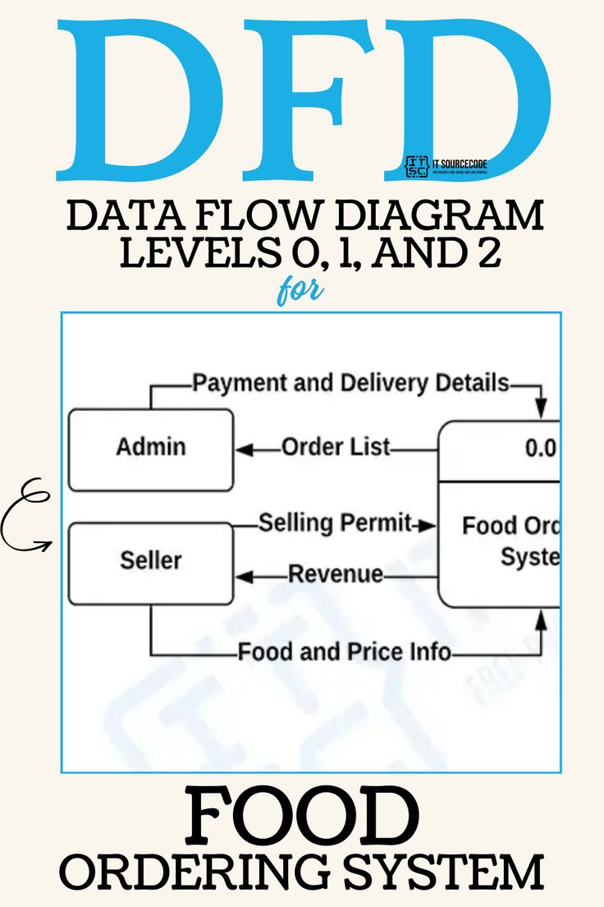

**User Stories**

**User Story Table –** **OrderOnTheGo: Your On-Demand Food Ordering Solution**

|  |  |  |  |  |  |
| --- | --- | --- | --- | --- | --- |
| **User Type** | **Functional Requirement (Epic)** | **User Story / Task** | **Acceptance Criteria** | **Priority** | **Release** |
| |  | | --- | | **Customer** |  |  | | --- | |  | | |  |  |  | | --- | --- | --- | | |  | | --- | |  |  |  | | --- | | Restaurant Discovery | | | As a customer, I can search for restaurants by cuisine and location. | Search results return relevant doctors. | High | Sprint-1 |
| **Customer** | Order  Management | |  | | --- | | As a customer, I can place, modify,  or cancel food orders. |  |  | | --- | |  | | |  | | --- | | Order status updates  accordingly. |  |  | | --- | |  | | Medium | Sprint-2 |
| |  | | --- | | **Restaurant**  **Owner** |  |  | | --- | |  | | |  | | --- | | Schedule Management |  |  | | --- | |  | | |  |  |  | | --- | --- | --- | | |  | | --- | | As a restaurant owner, I can set/update my opening hours and availability. |  |  | | --- | |  | | | |  | | --- | | Changes reflect instantly in ordering system. |  |  | | --- | |  | | High | Sprint-1 |
| **User** | Messaging | |  | | --- | | As a user, I can chat with customer support or restaurants in real-time. |  |  | | --- | |  | | Messages appear instantly. | Medium | Sprint-2 |
| **Admin** | Profile Management | As a Admin, I can update my profile. | Changes are saved successfully. | High | Sprint-2 |
| **Customer** | Payment Processing | As a customer, I can securely pay for my orders online | Payment recorded and shown in transaction history. | High | Sprint-2 |
| **Customer** | |  | | --- | |  |  |  | | --- | | Review System | | As a customer, I can leave a review after order delivery. | Review appears on profile. | Medium | Sprint-2 |
| **Admin** | User Moderation | |  | | --- | | As an admin, I can view reports and take action on users/restaurants. |  |  | | --- | |  | | Actions and logs are stored. | High | Sprint-1 |